**XML BRUSTING CONTROL FILE IN ORACLE XML REPORT**

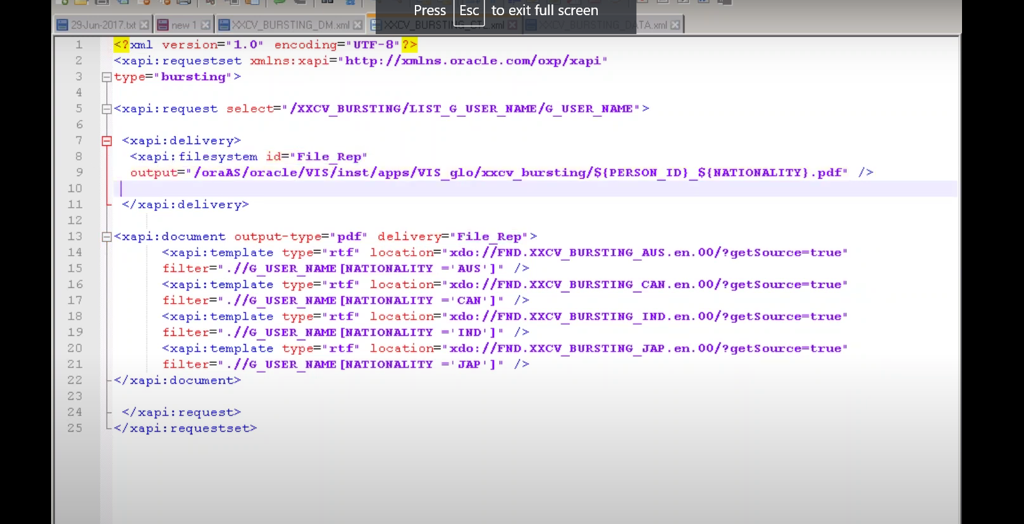

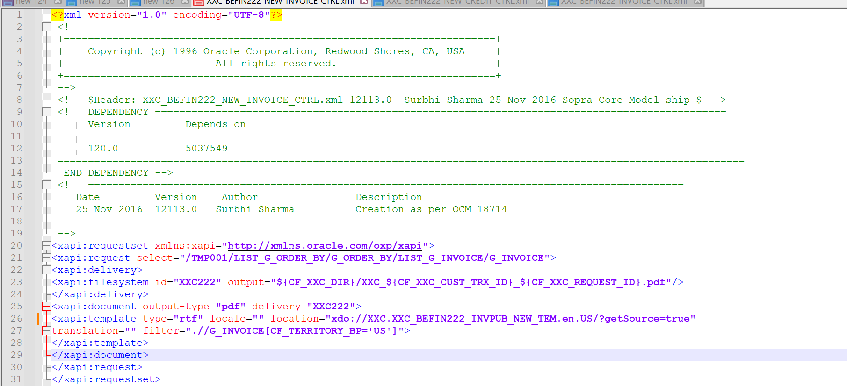

request select="/TMP001/LIST_G_ORDER_BY/G_ORDER_BY/LIST_G_INVOICE/G_INVOICE">

TMP001 - Top level tag

LIST_G_ORDER_BY – List level tag

G_ORDER_BY - Group level tag.

This tag we can find in xml output file of concurrent program.

<xapi:delivery>

<xapi:filesystem id="XXC222" output="${CF_XXC_DIR}/XXC_${CF_XXC_CUST_TRX_ID}_${CF_XXC_REQUEST_ID}.pdf"/>

</xapi:delivery>

filesystem id="XXC222" -- This is delivery ID , if there is multiple delivery then id should be unique.

output="${CF_XXC_DIR}/XXC_${CF_XXC_CUST_TRX_ID}_${CF_XXC_REQUEST_ID}.pdf"/>

in output tag we can provide file storage location with file name.

**Supported Delivery Methods**

·       Email

·       Fax

·       Printer

·       File System

**Unsupported Delivery Methods**

·       FTP

·       HTTP

·       WebDAV

<xapi:document output-type="pdf" delivery="XXC222">

<xapi:template type="rtf" locale="" location="xdo://XXC.XXC_BEFIN222_INVPUB_NEW_TEM.en.US/?getSource=true"

translation="" filter=".//G_INVOICE[CF_TERRITORY_BP='US']">

</xapi:template>

location="xdo://XXC.XXC_BEFIN222_INVPUB_NEW_TEM.en.US/?getSource=true"

XXC.XXC_BEFIN222_INVPUB_NEW_TEM - This is xml rtf template code name.

En- language

US – territory

<https://rpforacle.blogspot.com/2018/12/xml-bursting-control-file.html>

<https://oracleapps88.blogspot.com/2012/09/xmlpublisher-bursting-in-oracle.html>

YOU TUBE VEDEO - <https://youtu.be/-Znxm-bA_Ts?si=bhH9CbAif8nXnpkE>

chrome-extension://efaidnbmnnnibpcajpcglclefindmkaj/<https://www.strsoftware.com/wp-content/uploads/2011/09/Oracle-EBS-and-BI-Publisher-Report-Creation-Bursting-and-Delivery.pdf>